

TASK 2
ICT703: Programming
Bank Transaction Fraud Detection System
Student name: Adam Heier
Student ID: 1231535
Campus: Sunshine Coast
Tutor's name: Andrew Lang
Due date: 20 September 2026
Submission date: 20 September 2026
Word count: 5923
Adam Heier
ajh123@student.usc.edu.au

Table of Contents

1. Introduction 1
2. Problem Description 1
2.1. Purpose of the program 1
2.2. Main functionality 1
2.3. Transaction data used 1
2.4. Assumptions 2
2.5. Known limitations 2
3. Program Design 2
3.1. Overall program structure 2
3.2. Major classes and functions 2
3.3. Data structures 3
3.4. Techniques used from the course modules 4
3.5. Program flow 4
4. Libraries and Dependencies 4
5. Fraud Detection Rules 5
5.1. Rule 1 - High-value transactions 5
5.2. Rule 2 - Repeated declined transactions 5
5.3. Rule 3 - Multiple locations 5
5.4. Extending the core rules with advanced rules 6
6. Advanced Features 6
6.1. Advanced feature 1 - Enhanced data validation 6
6.2. Advanced feature 2 - Time-based fraud detection 6
6.2.1. Advanced feature 3 - Advanced storage and management 7
6.3. Advanced feature 4 - Configurable fraud rules 7
6.4. Advanced feature 5 - Customer account analysis 8
6.5. Advanced feature 7 - Summary statistics and reporting 8
7. Testing 8
7.1. Test plan 8
7.2. Test cases and results 9
7.3. Testing the complete program 10
8. Challenges and Future Improvements 10
8.1. Challenges during development 10
8.2. Future improvements 11
9. Reflection on Artificial Intelligence Use 11
9.1. Prompt 1 - Structuring the program 11
9.2. Prompt 2 - Debugging the whitespace check 11
9.3. Prompt 3 - Reviewing my own code for redundancy 12
9.4. Prompt 4 - Questioning the generated test data 12
9.5. Errors, limitations and verification 13

Table of Figures

Figure 1: Data structures used to store transactions, accounts and alerts. 3
Figure 2: Flowchart of the main program. 4
Figure 3: Console output of the detected suspicious activity. Every alert shows the account, the related transactions, the rule and the reason. 5

Introduction
Banks process very large numbers of transactions every day. Almost all of these transactions are normal, but a small number of them can show that a card or an account has been used by somebody who is not the real owner. Fraud analysts cannot read every single record by hand, so they need software that reads the transaction records automatically and points them to the small number of cases that are worth a closer look.
This report describes the Bank Transaction Fraud Detection System that I developed for ICT703 Assessment Task 2. The program is written in Python and reads fictional transaction records from a text file. It checks every record, keeps the valid records in memory, applies a set of fraud-detection rules to them and prints a clear list of the transactions and accounts that look suspicious. All data used in the program is fictional and was created for this assignment only.

Problem Description

Purpose of the program
The purpose of the program is to help a fraud analyst find suspicious activity in a file of bank transaction records. The program does not decide whether fraud really happened. It applies simple, clearly defined rules and produces a short list of transactions and accounts that a person should investigate. Every alert includes the reason why it was created, so the analyst can understand the decision without reading the program code.

Main functionality
The program provides the following functionality:
- It reads transaction records from a text file and handles a missing, empty or unreadable file without crashing.
- It validates every record, rejects the ones that do not meet the format with the line number and the reason and stores the valid ones in a list and in a dictionary grouped by account ID.
- It applies nine fraud-detection rules: the three core rules and six added as advanced features.
- It prints every alert with the account, the transactions, the rule and an explanation, then a summary and exports all four result sets to CSV files.

Transaction data used
The main data file transactions.txt contains 46 fictional records, the four examples from section 3.1 among them unchanged. Of the 46 records, 28 are valid and 18 are rejected. The file covers normal transactions, two approved amounts above $5,000, an account with four declines, two accounts used in three locations, one normal account that must not be flagged and eighteen kinds of invalid record.
The invalid records are mixed in between the valid ones, as they would be in a real export. This is deliberate: it shows that the program continues after a rejection instead of stopping and that the reported line numbers follow the file. The exception is the last record, a repeat of line 5, because a duplicate usually appears when data is added to a file twice.
A second file, accounts.csv, contains nine fictional customer accounts with the account type, the home location, the daily limit and the account status. It is a CSV file with a header row, so it is read with csv.DictReader. A third file, rules_config.json, contains the thresholds, the rule names and the severity levels. All three files are in the same folder as the program.

Assumptions
- Every record is on one line, fields separated by '|'. Lines starting with '#' are comments and a line starting with 'timestamp' is the header.
- All amounts are in Australian dollars and all timestamps are in the same time zone, so values can be compared directly.
- Records are processed in file order and each transaction ID is unique.
- The daily limit in the account file applies to the total of the approved transactions of one calendar day.

Known limitations
- The rules are threshold based. They show unusual behaviour, not proven fraud, so false alarms are possible: an account used during a holiday can trigger the multiple-locations rule.
- The whole file is loaded into memory. This is fine for a data file of this size, but it would not work for millions of records.
- There is no graphical interface and no database; results go to the console and to CSV files.
- Rule 3 counts locations over the complete file, as the task allows and ignores the time between them, so it cannot tell a holiday from an impossible journey.
- Amounts are floats. A real banking system would use the decimal module to avoid rounding differences.

Program Design

Overall program structure
I built the program with classes, because each part of the problem has its own data and behaviour. The solution is organised into three Python files, each with one job:

File | Purpose
main.py | The class FraudDetectionApp runs the six steps of the analysis and the print functions write the results to the console. Started with python main.py.
fraud_detection.py | All the program logic in eight numbered sections. It writes nothing to the console, which is why the same classes serve main.py and test.py.
test.py | 45 automatic test cases. It imports from fraud_detection.py and does not need main.py.

The three files depend on each other in one direction only: main.py and test.py both import from fraud_detection.py, which imports nothing from the program itself. Separating the logic from the output was a deliberate decision, because it makes every class testable on its own.
Only FraudDetectionApp is a class in main.py. The print functions keep no data of their own, so they are functions. I first wrote them as methods of a ResultPrinter class, but that class had no attributes and never used self.
Inside fraud_detection.py the classes are grouped in eight numbered sections, in the order in which the program uses them: helper functions, the data model, the rule configuration, the validation, the file loading, the storage, the detection rules and the summary statistics. The same list stands at the top of the file, so a reader can jump straight to a section.

Major classes and functions
Three kinds of file problem are handled in one place, in read_record_lines(): a missing file, a file that cannot be decoded as text and a file without any usable record. All three raise the same DataFileError, so main.py needs one except block to show a clear message instead of a Python error. Tests 2 to 4 check each case.

Class or function | What it does
FraudDetectionApp.run() | Runs the whole analysis in six steps, from loading the configuration to exporting the CSV files.
TransactionValidator.validate() | Checks one record and returns a Transaction, or raises a ValidationError with the field and the reason.
TransactionLoader.load() | Reads the file line by line and puts valid records into the store, invalid ones into a separate list.
TransactionStore.add() | Adds a transaction to the list and to the account dictionary.
FraudDetector.run_all_rules() | Runs rules 1 to 5; AccountAnalyser.run_all_checks() runs rules 6 to 9 against the customer account file.
FraudDetector._first_group_in_window() | Finds the first group of transactions inside a time window; used by rules 4 and 5.
SummaryReport.build() | Calculates the summary statistics and returns them as a dictionary.

Data structures
Every valid record becomes a Transaction object, stored twice inside TransactionStore: in the list transactions, which keeps the file order and serves rule 1 and in the dictionary transactions_by_account, which serves every rule that works on one account and avoids searching the whole list again. The name differs deliberately from the accounts dictionary in AccountAnalyser, which holds Account objects.
The alerts are kept in a second class, AlertStore, so that the analysis never changes the original transaction data. Rejected records are kept in a third list of InvalidRecord objects.
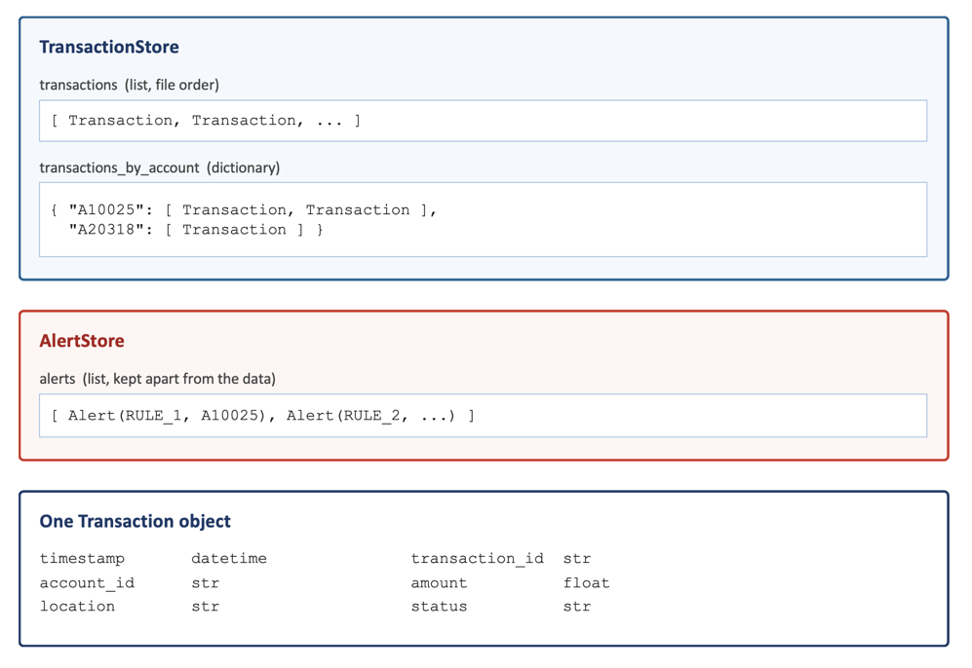
Figure 1: Data structures used to store transactions, accounts and alerts.

Techniques used from the course modules
The program uses the techniques from the module topics rather than libraries that hide the work. Module 2 supplies the docstring header of every file and the end-of-line comments on the constants; module 5 the file reading; module 8 the csv module (csv.DictReader reads accounts.csv by column name), json.load() for the configuration and the testing vocabulary of section 7.1. From module 6 come the three data structures: the dictionary that groups transactions by account, the set that counts an account once and the (line number, text) tuples. Module 7 supplies the default and keyword arguments and the main() entry point, module 9 the twelve classes. Pandas (module 10) and MySQL (module 11) were left out on purpose: both would have to be installed or set up and the task asks for a program that runs after extraction without changes.

Program flow
Figure 2 shows the flow of the main program. The loop over the lines of the transaction file is the part that is repeated for every record; the detection rules run once, after all records have been read and stored.
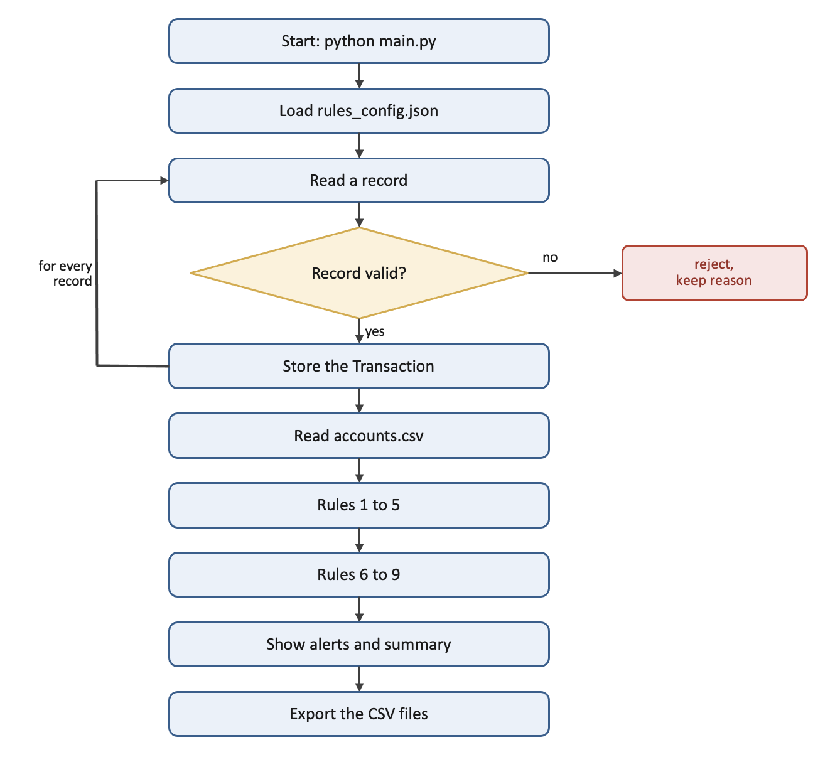
Figure 2: Flowchart of the main program.

Libraries and Dependencies
The program uses only modules from the Python Standard Library. No additional libraries have to be installed with pip and the program runs on any computer with Python 3.8 or newer.
datetime converts the timestamp text into a datetime object with strptime() and timedelta gives the time windows of rules 4 and 5. json reads the settings from rules_config.json. csv supplies DictReader for accounts.csv and writer for the exported result files. os checks the data files, creates the output folder and makes the relative paths work from any folder through chdir() and path.abspath(__file__).

The program is started with the command python main.py and the tests with python test.py. The data files are in the same folder as the program and are opened with relative paths such as transactions.txt, so the program runs after extraction without any changes. Before anything else, main() calls use_program_folder(), which changes to the folder that holds the program files. This means the relative paths also work when the program is started from a different folder or from an editor. The four CSV result files are written into a subfolder named output, which the program creates by itself.

Fraud Detection Rules
All detection rules are written as separate methods that return a list of Alert objects. None of the rules prints anything itself, which means that each rule can be tested on its own and that the output format can be changed in one place. The thresholds are not written into the code; every rule reads its threshold from the configuration object.

Rule 1 - High-value transactions
Rule 1 flags a single transaction that has the status APPROVED and an amount above the threshold of $5,000. The rule works on the list of all transactions, because it looks at one record at a time and does not need the account grouping.
for transaction in self.store.transactions:
if transaction.is_approved() and transaction.amount > limit:
reason = (f"The approved amount of ${transaction.amount:,.2f} "
f"exceeded the ${limit:,.2f} threshold.")
alerts.append(make_alert(…))
Both conditions are needed. A declined transaction of $9,000 was never paid out, so it is not flagged by this rule. The comparison uses the greater-than operator, which means that a transaction of exactly $5,000.00 is not flagged, which test 15 checks. In the sample data the rule creates two alerts:
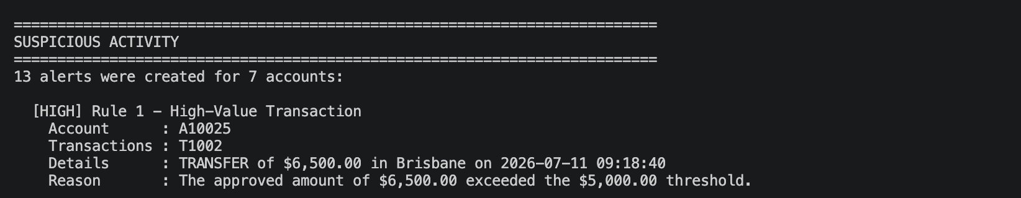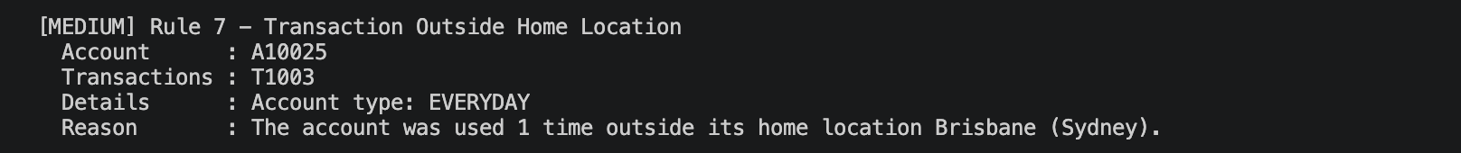
Figure 3: Console output of the detected suspicious activity. Every alert shows the account, the related transactions, the rule and the reason.

Rule 2 - Repeated declined transactions
Rule 2 works on accounts, not on single transactions. For every account the program collects the declined transactions and creates one alert if there are four or more, listing every relevant transaction ID.
One decline is normal, for example a wrong PIN. Four on the same account can mean somebody is trying card details that do not belong to them. A20318 has four declined online purchases and is flagged; A40199 has one and is not.

Rule 3 - Multiple locations
Rule 3 counts the different locations of one account. I used a list and not a set, because a list keeps the order in which the locations were used, which reads better in the alert.
Account A30712 was used in Sydney, Melbourne and Perth on the same day, A70455 in Darwin, Alice Springs and Katherine; both are flagged. A10025 was used in two locations only and is not.

Extending the core rules with advanced rules
The core rules count transactions over the whole file. Rules 4 and 5 add the time dimension, so they separate four declines within 23 minutes from four spread over a day. Rules 6 to 9 add information that is not in a transaction record at all, by comparing it with the account file. All nine use the same Alert class and AlertStore, so output, export and statistics treat them identically.
Some rules overlap on purpose. Four declines within 30 minutes trigger rules 2 and 4 and an account used in several cities often triggers rules 3 and 7. I did not suppress the second alert, because the rules answer different questions: rule 2 says the account has a pattern of declines, rule 4 says they came in a burst, which is the stronger signal and carries HIGH instead of MEDIUM. The statistics are not distorted, because suspicious_account_ids() uses a set: A20318 appears in two alerts but counts once.

Advanced Features
I implemented six of the advanced features. They are all part of the same program and are all covered by the test program.

Advanced feature 1 - Enhanced data validation

The validator has two modes, selected in the configuration file and printed at startup. Core mode applies only the basic checks: field count, non-empty IDs, a valid transaction type and status and a numeric amount greater than zero. Enhanced mode additionally validates every field against the required formats: the timestamp via datetime.strptime() in a try/except block, transaction_id (T plus four digits) and account_id (A plus five digits) through the shared method _check_id, the amount for at most two decimal places and a non-empty location.

Enhanced mode adds five further checks: duplicate transaction IDs and duplicate complete records – both tracked in dictionaries keyed on the ID or on the whole line, so the message names where it first occurred – missing or additional fields, inconsistent capitalisation such as transfer (compared with value.upper(), so the message can suggest the correct spelling) and additional whitespace, where a field may carry at most one space on each side of its value.

Rejected records are stored as InvalidRecord objects and exported to output/invalid_records.csv. Processing always continues with the next record, so one bad line never stops the analysis; in the sample data the rejections range from line 6 to line 50.

Two checks overlap deliberately: an identical record repeats the earlier transaction ID, so the duplicate-ID check would catch it anyway. The duplicate-record check runs first and gives the more useful message – "identical to line 5" points to a file merged twice, whereas "duplicate ID" suggests a numbering problem. One limitation remains: the whitespace check assumes exactly one space around each |, so a file aligned as a neat table would be rejected although its values are correct.

Advanced feature 2 - Time-based fraud detection
Rule 4 flags four or more declined transactions within 30 minutes. Rule 5 flags three or more approved transactions between $4,500 and $5,000 within 24 hours, because splitting one large payment is a known way of staying below a threshold.
Both rules need the same search: find a group of transactions inside a time window. Instead of writing that loop twice, one helper method serves both (code without docstring):
def _first_group_in_window(self, transactions, window, limit):
ordered = sorted_by_time(transactions)
for start in range(len(ordered)):
group = [ordered[start]]
for later in ordered[start + 1:]:
if later.timestamp - ordered[start].timestamp <= window:
group.append(later)
if len(group) >= limit:
return group
return []

Subtracting two datetime objects returns a timedelta, which can be compared directly with the window. Tests 29 and 30 use the same four declined transactions: between 11:02 and 11:24 an alert is created, spread from 09:00 to 15:00 none is.
Limitation: the helper stops at the first group it finds, so an account receives at most one alert per rule even with several separate bursts.

Advanced feature 3 - Advanced storage and management
Suspicious activity is stored separately from the valid transactions. AlertStore provides filter_by_rule(), filter_by_account(), suspicious_account_ids(), suspicious_transaction_ids() and sorted_by_severity(); TransactionStore provides find_by_id(), filter_by_status() and sorted_by_amount().
These methods are not only there for the tests: main.py uses them in two sections of the normal output. print_largest_transactions() calls sorted_by_amount() to show the five largest amounts and show_transaction() calls find_by_id() and filter_by_account() to look up one transaction together with the alerts on its account.
suspicious_account_ids() also answers a requirement of advanced feature 7: it collects the IDs in a set, so account A50876, which triggers rules 5 and 6, counts as one suspicious account.
Both stores can export their content to CSV. The program writes four files into a subfolder named output: valid_transactions.csv, invalid_records.csv, alerts.csv and summary_report.csv. All four exports use the same helper function write_csv(), which also creates the output folder the first time the program runs, so the code for writing a CSV file only exists once.

Advanced feature 4 - Configurable fraud rules
All thresholds, rule names and severity levels are stored in rules_config.json and are loaded when the program starts:

{
"thresholds": {
"high_value_amount": 5000.00,"declined_count": 4,… },
"rule_names": {
"RULE_1": "Rule 1 - High-Value Transaction",…},
"severities": {
"RULE_1": "HIGH", "RULE_2": "MEDIUM", "RULE_3": "MEDIUM",},
"options": {
"enhanced_validation": True,
},
}

The configuration reaches every part that shows a rule name. SummaryReport receives the RuleConfig object and builds its labels with config.rule_name(), so a name changed in the file changes in the alerts and in the summary at the same time.
The class RuleConfig first fills itself with built-in default settings and then updates each section with the values from the file. This has two advantages: a configuration file that only contains one threshold still works and a missing or damaged file does not stop the program. In that case the defaults are used and a warning is printed. Tests 36 to 38 check this behaviour, including a test that runs rule 1 twice on the same transaction of $2,500 - with the standard threshold no alert is created and with a threshold of $1,000 one alert is created.

Advanced feature 5 - Customer account analysis
The second data file accounts.csv holds the columns account_id, account_type, home_location, daily_limit and account_status. It is read with csv.DictReader rather than by splitting the line by hand, so every row arrives as a dictionary and a field is read by its column name.
The class AccountAnalyser compares the transactions with this information and adds four rules:
- Rule 6 adds up the approved amounts of each calendar day and compares them with the daily limit. Account A50876 spent $14,500.00 on 2026-07-12 with a limit of $10,000.
- Rule 7 flags transactions outside the home location.
- Rule 8 flags any transaction on an account whose status is not ACTIVE: A60234 is SUSPENDED but has two withdrawals.
- Rule 9 flags an account ID that is not in the account file at all, such as A90123.
If the account file is missing, the program warns, skips rules 6 to 9 and continues, so the advanced feature never breaks the core program.

Advanced feature 7 - Summary statistics and reporting
SummaryReport collects all the statistics listed in the task description. They are kept in a dictionary that feeds both the console output and the CSV export, so the two can never disagree.
The summary is exported to output/summary_report.csv. I chose CSV because it can be opened in Excel and does not need an additional library, which keeps the program dependency free.

Testing

Test plan
test.py runs 45 automatic test cases without user input. All test data lives inside test.py, so no extra files are needed. The class TestRunner compares an expected value with an actual one and prints feature, input, both values and the outcome.
The tests follow the vocabulary from module 8: black-box tests with positive and negative cases in every group, equivalence partitioning for the validation (each rejection reason is one class of invalid input, so one record per class is enough) and boundary value analysis for the rules, because a threshold is where a wrong comparison operator hides.
The test plan follows the structure of the program. Each group of tests covers one part and the groups are run one after the other:

Tests | Group | What is tested
1 - 4 | File handling | The main data file, a missing file, an empty file and a file that is not valid text.
5 - 13 | Core data validation | A valid record and the seven rejection reasons of section 4.2.
14 - 20 | Core fraud-detection rules | Rules 1 to 3 with suspicious data, boundary values and a normal account.
21 - 28 | AF 1 - Enhanced validation | Core against enhanced mode, the format checks, duplicates and one test that runs every check against the data file.
29 - 32 | AF 2 - Time-based rules | Rules 4 and 5, inside and outside the time window.
33 - 35 | AF 3 - Storage and management | Search and sort methods and that an account is only counted once.
36 - 38 | AF 4 - Configurable rules | Missing file and one transaction with two different thresholds.
39 - 42 | AF 5 - Customer accounts | Rules 6 to 9 against accounts.csv.
43 - 45 | AF 7 - Summary statistics | The calculated totals and the CSV export.

The boundary tests check the exact comparison operator of each rule: exactly $5,000.00 (test 15), three declines instead of four (test 17), two locations instead of three (test 19). Test 20 runs all core rules on a normal account and expects zero alerts and test 28 sends the complete data file through the validator, covering all eleven validation checks at once.
All test records are built by one helper function with a valid default for every field, so a test names only the field it is testing:
def record(tid="T3001", account="A10025", kind="TRANSFER", amount="850.00",
place="Brisbane", status="APPROVED",
time="2026-07-11 09:15:23"):
"""Build one transaction record line.Every field …”””
return (f"{time} | {tid} | {account} | {kind} | {amount} | "
f"{place} | {status}")

Test cases and results
The table shows all tests with test input and outcome: the boundary tests and the decisive case of each advanced feature, with the input, the expected result and the actual result. The remaining tests of the 45 follow the same pattern within their group. Record inputs are shown with the field that was changed:

# | Feature tested | Test input | Expected and Actual
1 | load: valid file | transactions.txt | 46 read, 28 valid
2 | load: missing file | missing.txt | DataFileError
3 | load: empty file | empty file | DataFileError
4 | load: unreadable file | binary file | DataFileError
5 | validate: valid | valid record T3001 | accepted
6 | validate: wrong field count | record with 6 fields | rejected (record)
7 | validate: invalid type | T3001: transaction_type = BITCOIN_SWAP | rejected (transaction_type)
8 | validate: bad status | T3001: status = REJECTED | rejected (status)
9 | validate: text amount | T3001: amount = abc | rejected (amount)
10 | validate: zero | T3001: amount = 0.00 | rejected (amount)
11 | validate: negative | T3001: amount = -50.00 | rejected (amount)
12 | validate: empty ID | record: transaction_id = (empty) | rejected (transaction_id)
13 | validate: empty account | T3001: account_id = (empty) | rejected (account_id)
14 | Rule 1: above limit | T4002 approved, $6,500.00 | 1 alert for T4002
15 | Rule 1: exactly $5,000 | T4003 approved, $5,000.00 | 0
16 | Rule 2: four declines | 4 declines for A20318 | 1
17 | Rule 2: three declines | 3 declines for A20318 | 0
18 | Rule 3: three locations | Sydney, Melbourne, Perth | 1
19 | Rule 3: two locations | Sydney, Melbourne | 0
20 | normal account: no alert | A40199, 3 small amounts, one city | 0
21 | AF1: ID format, core mode | transaction_id = TX999 | accepted
22 | AF1: ID format, enhanced | transaction_id = TX999 | rejected (transaction_id)
23 | AF1: account ID format | account_id = A8051 | rejected (account_id)
24 | AF1: timestamp format | 11/07/2026 09:15:23 | rejected (timestamp)
25 | AF1: capitalisation | transaction_type = transfer | rejected (transaction_type)
26 | AF1: extra whitespace | account_id = "A10025 " (2 spaces) | rejected (record)
27 | AF1: duplicate ID | T3001 used twice | duplicate ID, already used on line 1
28 | AF1: all checks, data file | transactions.txt | 18 rejected, 18 exported
29 | Rule 4: four in 30 min | 4 declines, 11:02 to 11:24 | 1
30 | Rule 4: four in 6 hours | 4 declines, 09:00 to 15:00 | 0
31 | Rule 5: three below $5,000 | $4,900 / $4,850 / $4,750 in one hour | 1
32 | Rule 5: only two amounts | $4,900.00, $4,850.00 | 0
33 | AF3: find_by_id | T2002 | 6500.0
34 | AF3: sorted_by_amount | highest first | T2002
35 | AF3: account counted once | 5 sample records | ['A10025']
36 | AF4: missing config file | no_such_config.json | built-in default settings
37 | Rule 1: $2,500 at $5,000 | threshold $5,000.00 | 0
38 | Rule 1: $2,500 at $1,000 | threshold $1,000.00 | 1
39 | Rule 6: above daily limit | A40199 spent $2,400, limit $2,000 | 1
40 | Rule 7: outside home location | A40199 in Perth, home Hobart | 1
41 | Rule 8: suspended account | A60234 is SUSPENDED | 1
42 | Rule 9: unknown account | A99999 | 1
43 | AF7: approved value | transactions.txt | $34,322.65
44 | AF7: accounts counted once | transactions.txt | 7
45 | export_to_csv | summary CSV | True

All 45 tests passed. The test program ends with the line "TEST SUMMARY: 45 tests, 45 passed, 0 failed.

Testing the complete program
The expected values in test.py were derived by hand from transactions.txt and accounts.csv before the tests were written, so the tests check what the program should do, not only what it currently does. Running main.py on the full data set gives 46 records read, 28 accepted, 18 rejected and 13 alerts for 7 accounts; A40199 is listed as normal, confirming that an ordinary account is not flagged:

==========================================================================
ACCOUNT OVERVIEW
==========================================================================
Account Transactions Alerts Result
A10025 4 2 SUSPICIOUS
A20318 6 2 SUSPICIOUS
A30712 4 2 SUSPICIOUS
A40199 4 0 normal
A50876 3 2 SUSPICIOUS
A60234 2 1 SUSPICIOUS
A70455 4 3 SUSPICIOUS
A90123 1 1 SUSPICIOUS

I also checked the style with pycodestyle. The command python -m pycodestyle --max-line-length=79 *.py reports no problems for any of the three files.

Challenges and Future Improvements

Challenges during development
Deciding how to store the data was the first challenge. A list of dictionaries worked for rule 1, but rules 2 and 3 need all transactions of one account, so TransactionStore now keeps both a list and a dictionary grouped by account ID. I also moved to a Transaction class, because transaction.amount reads better than record["amount"].
The second challenge was a bug in my whitespace check, which searched the whole line for two spaces next to each other. Three records were rejected for 'additional whitespace' although the real problem was an empty field - an empty field between two separators produces exactly those two spaces. I rewrote the check to look at each field separately and skip empty ones.
The third challenge was the time window of rules 4 and 5. Comparing only neighbouring transactions does not answer 'were there four declines within 30 minutes', so I wrote _first_group_in_window(), which starts at every transaction and counts how many later ones lie inside the window - once, for both rules.
The fourth problem appeared when I started the program from the folder above the extracted ZIP: it stopped with 'The file transactions.txt was not found'. A relative path is resolved from the folder the program was started in, not the one it is stored in. use_program_folder() finds the program folder with os.path.abspath(__file__) and changes into it; I then ran it from three folders with the same result.

Future improvements
- An interactive menu to search alerts by account, rule or severity. The filter methods already exist.
- Store the alerts in a database with an investigation status, so several runs can be compared.
- Improve rule 3 with the time between two locations: Sydney and Perth within ten minutes is impossible, within a week is normal for a business traveller.
- Use the decimal module instead of float for the amounts, which would remove the small rounding differences that floating point numbers can produce.
- Write the alerts to a timestamped log file, so the program can run as a scheduled job.
- Read the input file line by line instead of loading it all, so larger files could be processed.

Reflection on Artificial Intelligence Use
I used Claude Code by Anthropic during this assessment for brainstorming, explanations of Python concepts, rewriting and upgrading my code, help with debugging, generating fictional test data and editing this report. Every suggestion was read, changed where necessary, run and tested before I kept it and I did not use AI to produce work that I cannot explain. Only fictional data was used in any prompt.

Prompt 1 - Structuring the program
Prompt: "i have to write a python program that reads bank transactions from a text file, validates them, stores them and then applies fraud rules. (requirements 4 + 5 pasted in) i'm a beginner but i want to use OOP. which classes would you use and how do i store the transactions so i can go through them per account later?"
Output: four classes — one transaction, one validator, one store, one detector — and for the storage a list of all transactions plus a dictionary grouped by account ID. It also recommended collections.defaultdict.
Follow-up: "what exactly does defaultdict do? we didn't have that in the course" — it explained that the dictionary creates the missing list automatically on first access.
How I used it: I kept the four classes and the list-plus-dictionary storage and added RuleConfig, AlertStore, AccountAnalyser and SummaryReport myself as the advanced features grew. I rejected defaultdict: it saves two lines, but it was not part of the course and I wanted to be able to explain every line, so TransactionStore.add() creates the list with a plain if. Keeping the alerts in a separate class instead of setting a flag on each transaction was my own decision — the analysis should not modify the records it analyses.

Prompt 2 - Debugging the whitespace check
Prompt: " "3 records get rejected with 'additional whitespace' but they are actually broken because transaction_id / account_id / location are empty. my check is if ' ' in line: raise ValidationError(...). why does that match?"
Output: in ... | T1035 | | TRANSFER | ... the space before the separator and the space after it sit next to each other, which is exactly the double space the condition looks for. The suggestion was to check each field on its own and skip the empty ones, since an empty field already has its own error message.
How I used it: I printed the split fields of one of those records, which confirmed the explanation straight away. I rewrote _check_spacing() so that it receives the raw fields instead of the whole line and skips empty values. This was the most useful answer of the assessment, because the fault was in my assumption about the data, not in the syntax — the AI did not find a bug in my code, it found a bug in my reasoning.

Prompt 3 - Reviewing my own code for redundancy
Prompt: "is anything in my code unnecessary or redundant? the task description is attached" (sent with all three .py files and the assessment PDF.)”
Output: it found that the nine rule names exist twice (a module-level RULE_LABELS dictionary and rule_names in the configuration file), which also means the summary report ignores renamed rules and works against the configurable-rules feature; that write_temp_file() and write_temp_bytes() in test.py duplicate the same folder-creation logic; that SummaryReport.build() is computed twice per run; that find_by_id() and sorted_by_amount() are never called from main.py; and one trailing whitespace character. It also argued against removing two things I had expected it to flag: the duplicate-record check (subsumed by the duplicate-ID check, but it produces the more specific message) and the overlapping alerts of rules 2 and 4.
How I used it: I acted on all of it. SummaryReport now builds its labels with config.rule_name() and RULE_LABELS is deleted, which meant widening the summary column from 40 to 52 characters — the price the review had predicted. write_temp_bytes() was merged into write_temp_file(), build() caches its result, test.py got a LINE_WIDTH constant, and TransactionStore.accounts was renamed to transactions_by_account because it holds transaction lists, not accounts. I also removed three parameters and a return value that nothing used. I verified the main change by renaming a rule in rules_config.json and confirming the summary follows, then re-ran both programs: 45 tests pass, the totals are unchanged and pycodestyle is clean.
The most valuable point was the one I had not seen as a defect at all: find_by_id() and sorted_by_amount() existed but were only ever called from the test program, and requirement 5.3 asks for search and sort to be fully integrated. Both are now used in the main program. Asking for criticism of my own code was more useful than asking for code — but the review listed a functional defect and a stray blank line as equal items, so deciding what mattered was still my job.

Prompt 4 - Questioning the generated test data
Prompt: "why are the first 28 lines all valid and everything after that broken? wouldn't it make more sense to mix them? sometimes broken, sometimes not"
Output: It agreed and gave two reasons I had not thought of. With all the broken records in one block at the end, the program could stop at the first rejection and nobody would notice, because the 28 valid records have already been read — so the file would not actually test requirement 5.1, that processing continues after an invalid record. And a continuous block would also pass if the program merely counted the records it processed instead of tracking the true line in the file; only scattered line numbers prove that, including the skipped comment and header lines.
How I used it: I had the file rearranged into timestamp order, so the invalid records now sit on lines 6, 12, 14, 20, 23, 25, 27, 28, 31, 34, 35, 38, 39, 41, 42, 46, 48 and 50. The first rejection is now on line 6 with 27 valid records still to come. I then compared the output before and after: 46 records read, 28 valid, 18 rejected, 13 alerts for 7 accounts — identical. Only two messages changed and those were the ones that should: Duplicate transaction ID 'T1001', already used on line 8 (line 6 before) and Duplicate record, identical to line 5 (line 4 before). That nothing else moved is a test result in itself: the time-window rules sort by timestamp internally, so they do not depend on the order of the file.
I kept one deliberate exception. The duplicated record is still the last line of the file although its timestamp belongs to the first day, because a repeated record realistically appears when an export is appended twice and keeping it at the end makes the duplicate check easy to demonstrate. Later I reduced the test data to 45 data sets.
What I learned from it: The AI-generated data covered every validation case correctly, but the way it was arranged quietly failed to test one of the requirements. Generated test data has to be judged by what it can prove, not only by whether it contains the right cases.

Errors, limitations and verification
The same conversation that produced the test data also showed the clearest limitations:
- The suggested 'normal' account would have been flagged by rule 1, so the assistant had not checked its own data against my rules. I rewrote that account with small amounts in one city.
- Two suggested transaction types, such as CREDIT_PAYMENT, do not exist in the task description. Fabricated values like this are easy to miss if the data is not checked line by line.
- Some suggestions were more advanced than the course material: defaultdict, dataclasses, regular expressions. I used plain dictionaries and string checks instead.
- An early suggestion returned a tuple of (transaction, error_message), which made the calling code hard to read. I used a ValidationError exception instead.

I verified the AI-assisted work in four ways: I compared the output with the data file by hand after every change, for example by counting the declines of account A20318 myself; I wrote a test case for every rule and every validation check, including boundary values and all 45 pass; I checked the style with pycodestyle against PEP 8; and I read every line and rewrote the parts I could not explain in my own words. All code and report content here is something I understand and can justify.

